Practical 05 Configure DHCP in Packet Tracer.

Step 1: Take one server and 9 end devices such as PC or laptop & one router. and set proper connections among them.

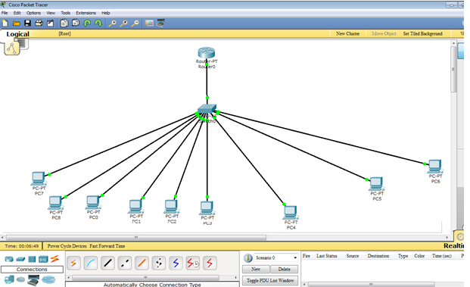

Step 2: apply DHCP on the router. The commands in sequence are as follows.

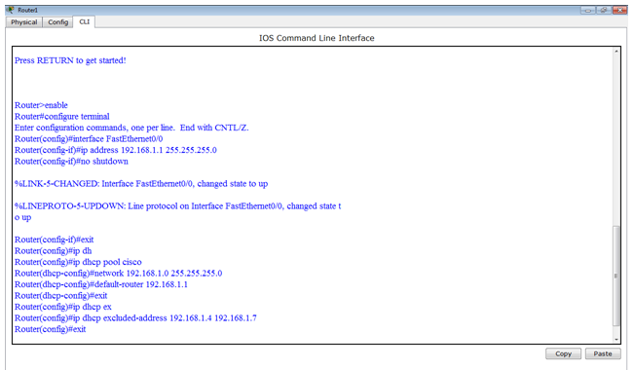

Step 3: Configure all pc as follows.( Select from Static to DHCP)

